REPLACE THIS SENTENCE WITH THE TITLE OF YOUR ABSTRACT
A. B. Author¹ and C. D. Author²
¹Affiliation (include full mailing address and e-mail address if desired) for first author, ²Affiliation for second author (full mailing address and e-mail address).

Introduction: Replace these instructions with the text of your abstract. Paper size is set to A4 (21x29.7cm). Page margins are set to be 2.5 cm all sides. The text will appear in two columns that are each ~7.5cm wide and 0.91cm separation. You should also check that the default font is Times New Roman 11pt for the main text (see Table 1). If you are including tables or figures, they must be imported into this file.
Please, limitate the abstract to a only one page.
Digital Formats: Any image file format that can be imported into this file will be acceptable for publication (Fig. 1). We ask that you use smaller-format files whenever possible.
The document should be less than 5 MB.
Heading Styles: The section heads in this template use the correct style (upper and lower case, bold, followed by a colon).
Bla bla bla bla bla bla bla bla bla bla bla bla bla bla bla bla bla bla bla bla bla bla bla bla bla bla bla bla bla bla bla bla bla bla bla bla bla bla bla bla bla bla bla bla bla bla bla bla bla bla bla bla bla bla bla bla bla bla bla bla bla bla bla bla bla bla bla bla bla bla bla bla bla bla bla bla bla bla bla bla bla bla bla bla bla bla bla bla bla bla bla bla bla bla bla bla.

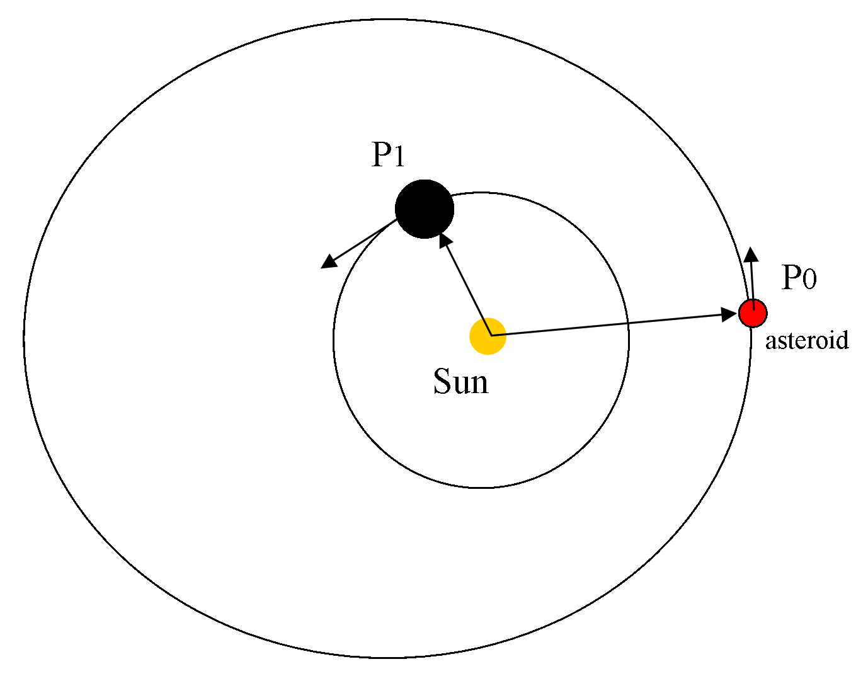
Figure 1. Two ellipses.

Bla bla bla bla bla bla bla bla bla bla bla bla bla bla bla bla bla bla bla bla bla bla bla bla bla bla bla bla bla bla bla bla bla bla bla bla bla bla bla bla bla bla bla bla bla bla bla bla bla bla bla bla bla bla bla bla bla bla bla bla bla bla bla bla bla bla bla bla bla bla bla bla bla bla bla bla bla bla bla bla bla bla bla bla bla bla bla bla bla bla bla bla bla bla bla bla.

 | Type | Size
Paper | A4 | 21x29.7cm
Columns | 2 | 7.5cm
Text | Times New Roman | 11pt
Table 1. Style.

Acknowledgments: bla bla bla bla bla bla bla blabla bla bla bla bla bla bla bla bla bla bla bla bla bla bla bla Bla bla bla bla bla bla bla bla bla bla bla bla bla bla bla bla bla bla bla bla bla bla bla.

If you have any questions or need assistance with preparation of your abstract, send an e-mail message to acm2017@fisica.edu.uy.

References: Use the brief numbered style common in many abstracts, e.g., [1], [2], etc. References should then appear in numerical order in the reference list, and should use the following abbreviated style:
[1] Author A. B. and Author C. D. (1997) JGR, 90, 1151–1154. [2] Author E. F. et al. (1997) Meteoritics & Planet. Sci., 32, A74.

Please DO NOT submit duplicates of your abstract via the submission form; should you find it necessary to replace or repair your abstract, send an email to acm2017@fisica.edu.uy with the new version. Only for well-founded reasons, a replacement of the abstract after the submission deadline will be considered.

Submit the .doc or .odt file, AS WELL as a .pdf file.

